5/17/2024

**Analyze IMS Standard Operating Procedures**

* **Installation**
  + The latest version of AIMS can be found on GitHub
    - <https://github.com/BioMEMS/AnalyzeIMS>
  + Clone the GitHub repository using GitHub desktop (or whichever process you prefer)
  + Several packages are necessary to utilize all the functions of AIMS:
    - Computer Vision Toolbox
    - Deep Learning Toolbox
    - Curve Fitting Toolbox
    - Image Processing Toolbox
  + If any of the above packages are not installed, some functions of AIMS will not work
    - All these packages should be available with the standard MATLAB license
  + Installing MATLAB packages
    - If you are not familiar with installing packages in MATLAB, follow the steps below
    - Under the “Apps” tab, click on the “Get More Apps” button to open the add-on explorer
      * A screenshot of a computer

        Description automatically generated



* + - In the add-on explorer, simply open and install all necessary packages
      * A screenshot of a computer

        Description automatically generated
* **Loading Data**
  + Run AnalyzeIMS.m in MATLAB. A figure should appear like the one below:
  + 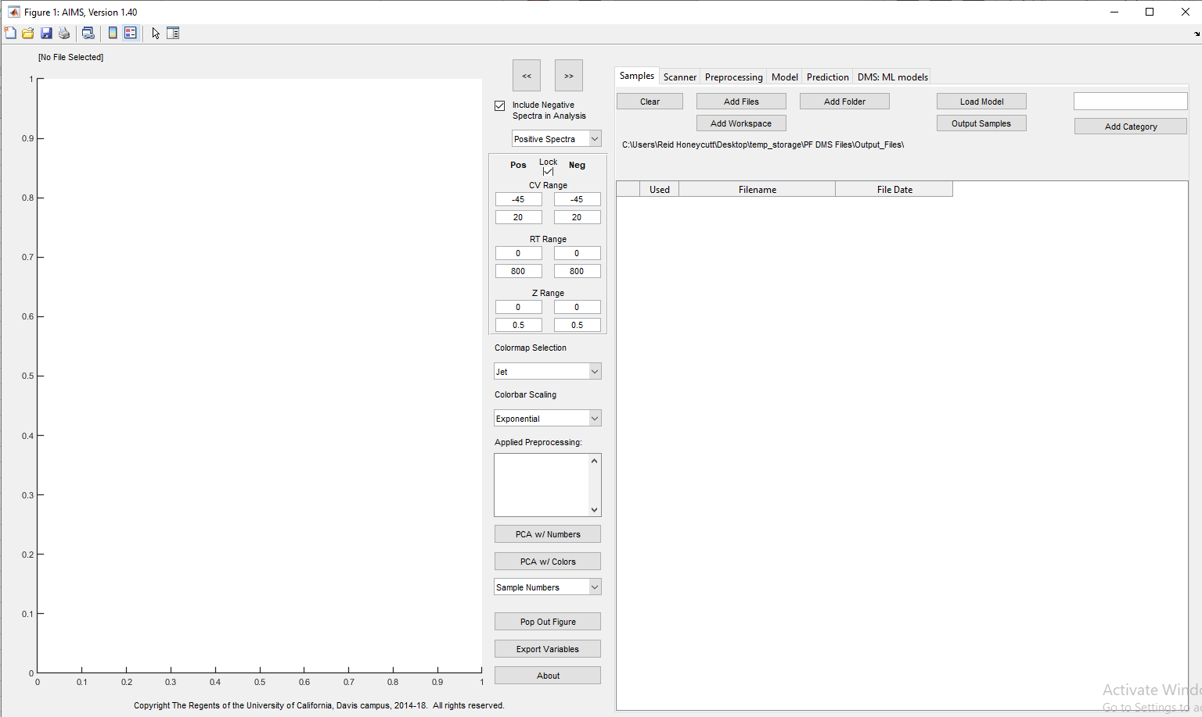
  + Click the “Add Files” or “Add Folder”. A pop-up window should appear:
  + A screenshot of a computer

    Description automatically generated
  + Select the files or folder full of files that you would like to load in.
    - Note: files must follow the correct naming convention. They must end in _Pos.xls, _Neg.xls, or _Hdr.xls.
      * Each file must have a _Pos, _Neg, and a _Hdr file associated with it for AIMS to load it in.
        + E.g. file1_Pos.xls, file1_Neg.xls, *and* file1_Hdr.xls
        + The _Pos and _Neg files contain the positive and negative spectra, respectively, and the _Hdr file contains metadata.
* **Analyzing Data**
  + A screenshot of a computer

    Description automatically generatedBefore data can be analyzed using the tools in AIMS, they must be labelled
    - The “Add Category” button can be used to add an additional column to the table for labelling your data
  + A screenshot of a computer

    Description automatically generatedOnce a new category has been added, new classifications can be created using the dropdown arrow